Web Services Lab
Table of Contents
Create a new Heroku App 1
Deploy your code to Heroku: 3
Writing your first web services 6
Hello World 6
Hello World with arguments 7
Writing a Web Service that connects to a Database 9
Setup the tables 9
Add end points that connect to the database 12
Run the web service locally 15
Decompose index.js 16
Hello End Point 16
Params End Point 17
Courses sql end point 18
Modularize the DB connection 20
Register Service 21
Setup Webservice to use JSON Web Tokens (JWT) 24
Setup the module and security key 24
Login Service 25

Create a new Heroku App
- Create a Heroku account at Heroku.com. I used my uw.edu as the Google Sign in.
- Log in to your Heroku account and go to https://dashboard.heroku.com/apps to create your first app. Make sure you select New>Create New App, not ‘Create New Pipeline’.
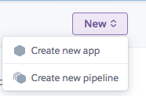
- Choose your application name, then create your app. Use the name:
uwnetid-services-backend
Once you’ve created your app, you’ll see a screen that looks like this:
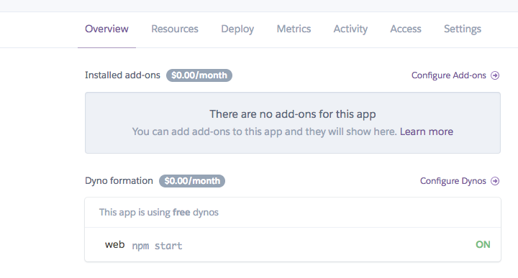
- Click the Overview tab then click “Configure Add-ons”. Then search for ‘Postgres’, and click on “Heroku Postgres” Make sure you choose “Hobby dev - free” for your type, otherwise you’ll have to pay. Click “Provision”. You’ll get 10,000 rows for free, which should be good enough for the extent of this lab. Mine looks like below:
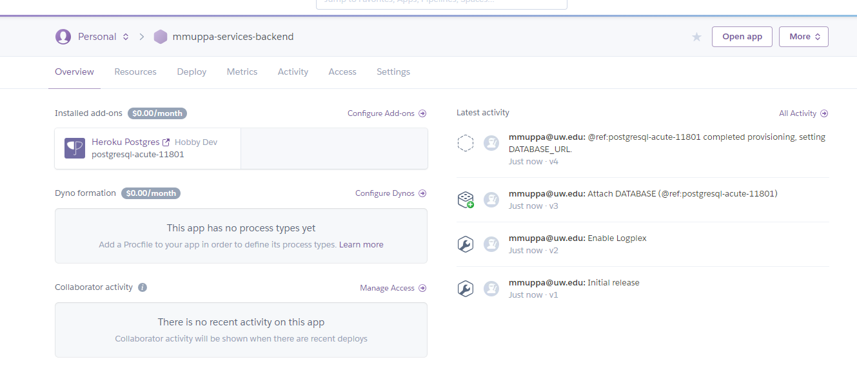

Deploy your code to Heroku:
- Heroku uses git for code deployment. We will use the Heroku CLI to deploy your code using git. Download and install for your operating system. You can get it from here:
https://devcenter.heroku.com/articles/heroku-cli

- This lab includes commands to run at the command line. They look like this and I would advise you type them in manually instead of copy/paste:
comand line steps
NOTE: There are multiple steps that use ‘single quotes’ in command line statements. Depending on your operating system and/or its setup, you may need to substitute with “double quotes”. Also, the single quotes inserted in this word document may not be allowed in your OS command line terminal, so it is suggested that you type each command out instead of copy/paste them.
- Open a command line terminal. Change directory to a location where you want to create a repository to locally store your web services.
- Login to Heroku CLI. This will ask you to login using the web browser.
heroku login
- Next, clone the git repository Heroku created for you via the command
heroku git:clone -a uwnetid-services-backend
- Back in the console, change directory into the newly cloned repository.
cd uwnetid-services-backend
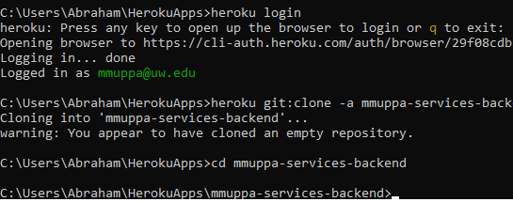

- In the lab assignment on Canvas, download the provided zip file. Unzip it and copy all of the enclosed files into the directory that was created by cloning the repository. Make sure that you move ALL files, there is a (.hidden) file.

- The following three commands will add, commit then DEPLOY your project to Heroku. You will need to repeat these steps anytime you need to deploy changes to the server. The screen shots following is a snippet of a successful deployment.
git add .
git commit -m “initial commit’
git push heroku master
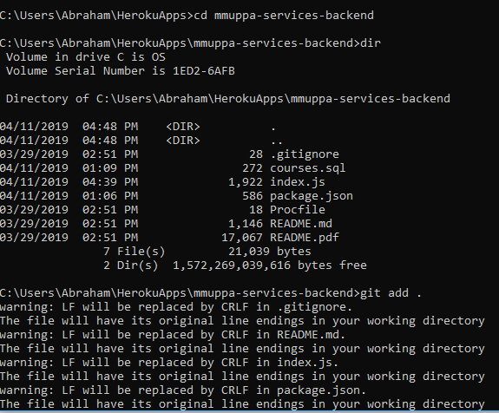
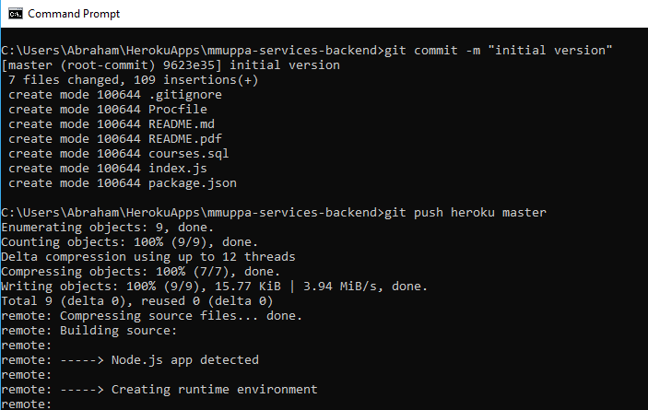

- The provided starter code includes an end point that returns an HTML web page. This is helpful to test if the web service is up and running. To view this page, type the following into a web browser:
https://uwnetid-services-backend.herokuapp.com/

Writing your first web services

Hello World
- Download and install WebStorm from https://www.jetbrains.com/webstorm/. This will be our IDE for web development. You can apply for a free educational license that’s valid for one year.
- You have been given the javascript file (index.js – entry point into the service, think main method almost), which has most of the code needed to run the backend with a few functions not completed yet. The zip file From Canvas contains all the needed files for a Node.js web service.
- Open WebStorm and open the folder that contains these files. You will have to install npm modules to be able test locally, which the IDE will automatically install.
- After that is done, go to EXPLORER section and open index.js and we will begin writing the JavaScript functions to handle the hello world web services.
- In the “TO DO” section of index.js, insert the following functions:

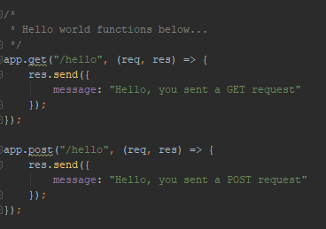

- SAVE index.js. Then, in the terminal, type the following commands:
git add .
git commit -m “added hello get and post”
git push heroku master
- Test that the web service is running. You can test three ways. First, in a web browser, navigate to: https://uwnetid-services-backend.herokuapp.com/hello
- Install and open Postman. In the URL field, enter the URL found in the previous step. Test both GET and POST.
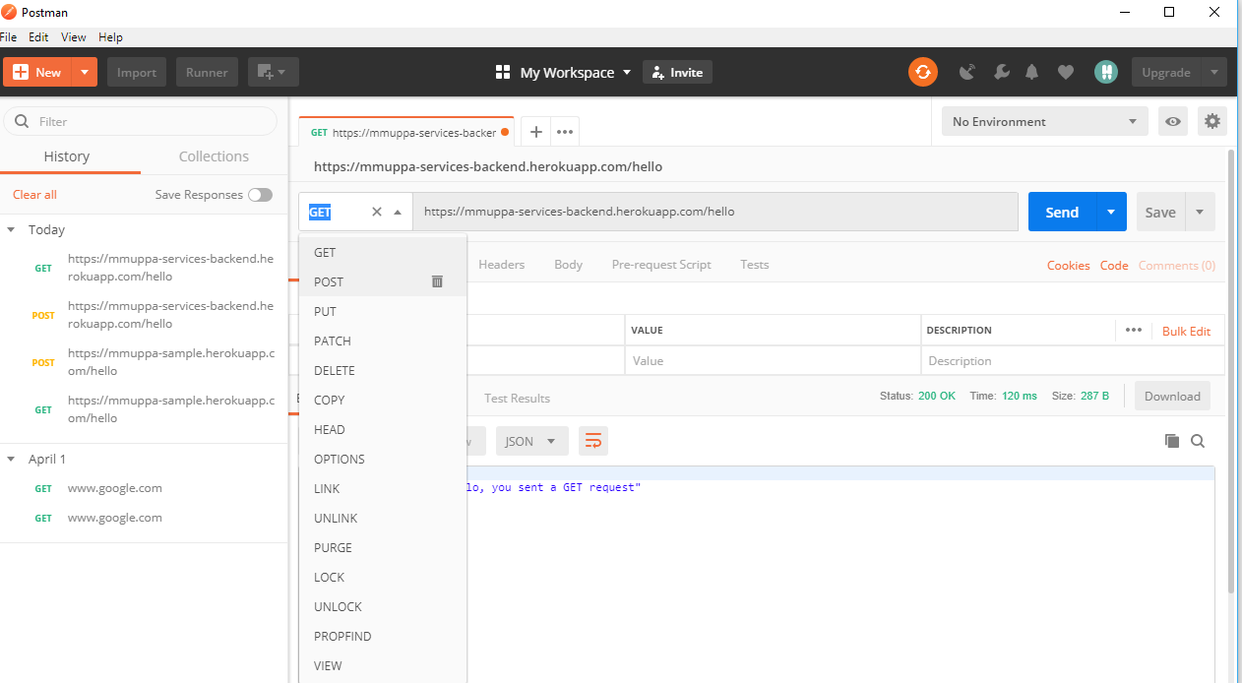

Hello World with arguments

- Add the following functions to index.js just below the hello functions:

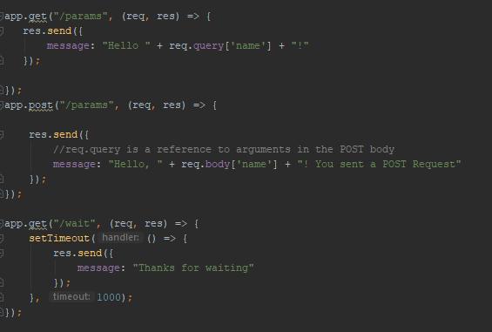
- SAVE index.js. Then, in the terminal, type the following commands:
git add .
git commit -m “add get/post with arguments”
git push heroku master
- Test that the web service is running. You can test three ways. First, in a web browser, navigate to: https://uwnetid-services-backend.herokuapp.com/params?name=yourname
- Open Postman. In the URL field, enter the URL found in the previous step. Test GET. To test a POST with arguments, you need to add the JSON message to the body of the message. Click Post > Body. Select raw, them JSON (application.json). Then add the following into the test area:
{
"name":"test"
}
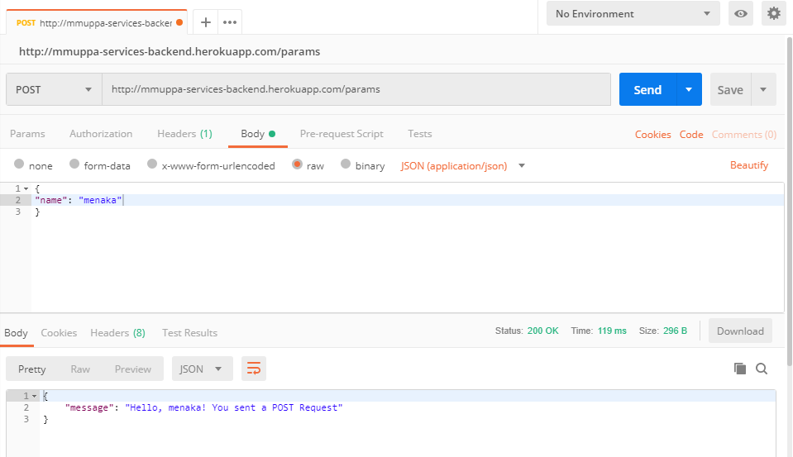

Writing a Web Service that connects to a Database

- Install Postgres on your local machine following the instructions for your OS. https://devcenter.heroku.com/articles/heroku-postgresql#local-setup .

Setup the tables
- In this section you will setup tables and manipulate data in a Postgres database. If you have little or no experience working with a database, (setting up tables, writing SQL commands such as SELECT, INSERT, DELETE, etc. etc.) it is highly recommended that you work through the SQL tutorial at w3schools:
  - https://www.w3schools.com/sql/
  - The tutorial may also serve as an excellent reference to forming SQL statements. I use it when writing SQL statements.
- In a previous step, you set up your Heroku app to include a Postgres database resource. You need to add tables to the database to store or retrieve any information. The files in the zip from the lab on canvas include an SQL script (courses.sql) that you can use to create your tables. Open the script in WebStorm and it includes tables that will be helpful to your lab. Feel free to use and alter this script for your project. The table that this portion of the lab uses is called Courses.

- Run the script on your Heroku app to setup the tables in the database. If this command doesn’t work, you will have to make sure the PATH is setup for your OS to find Postgres, From a console that is logged into Heroku and in the directory with the database script, type the following command:
heroku pg:psql --app uwnetid-services-backend < courses.sql
- The will result in multiple NOTICE messages. You can run Heroku pg:info to see if you have the add on setup. 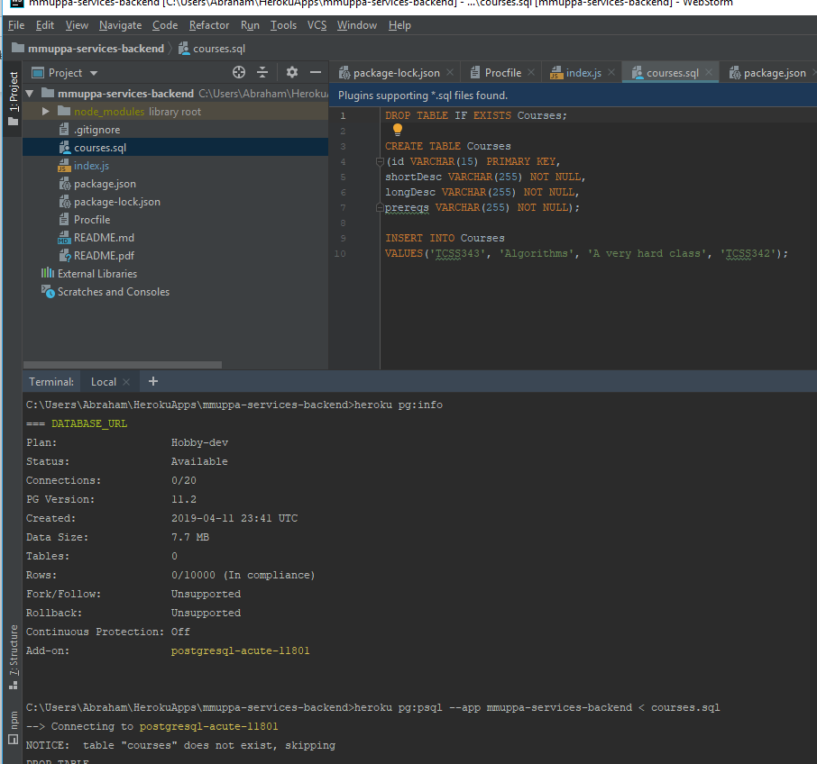
- If you want to run terminal commands on the database, you will need to enter the Postgres/Heroku database terminal. Type the following command:
heroku pg:psql
- You are now in the database terminal and may run commands to view your database tables. There are MANY GUI clients that will connect to your database. Feel free to use/try out any of them. For this lab, we will only use the terminal.
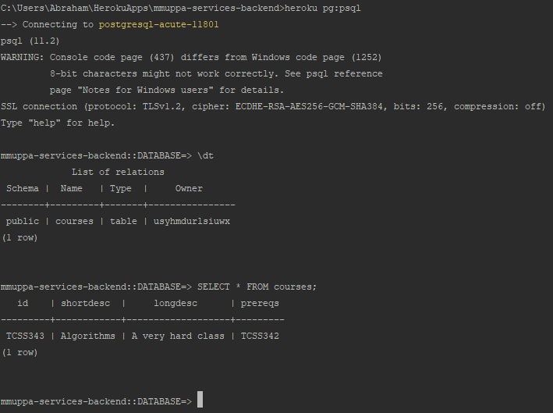
- To view the existing tables, type:
\dt
- To view other commands, type:
help
\?
\h

- Add an entry to the courses table using INSERT.
- View the newly added entry using SELECT.

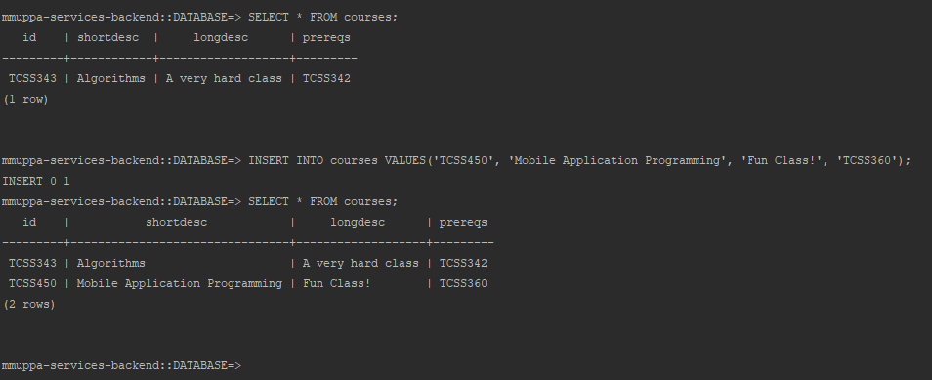
- Delete the entry using DELETE statement.
- Exit from the DATABASE terminal. Type:
\q
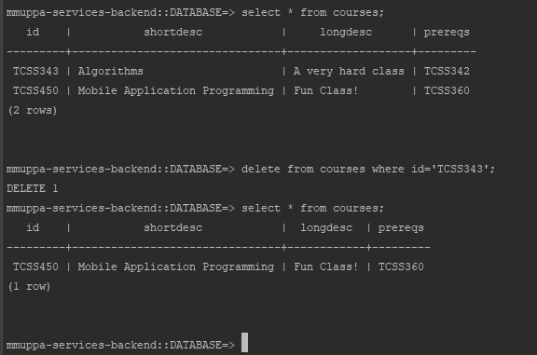

Add end points that connect to the database

- Add the following functions to index.js just below the wait function:
Syntax: https://www.npmjs.com/package/pg-promise
- app.post("/addcourse", (req, res) => {
// Parameters for the courses
let id = req.body['id'];
let shortdesc = req.body['shortdesc'];
let longdesc = req.body['longdesc'];
let prereqs = req.body['prereqs'];
if (id && shortdesc && longdesc && prereqs) {
db.none("INSERT INTO courses VALUES ($1, $2, $3, $4)", [id, shortdesc, longdesc, prereqs])
.then(() => {
//We successfully added the course, let the user know
res.send({
success: true
});
}).catch((err) => {
//log the error
console.log(err);
res.send({
success: false,
error: err
});
});
} else {
res.send({
success: false,
input: req.body,
error: "Missing required information"
});
}
});
app.get("/courses", (req, res) => {
db.manyOrNone('SELECT * FROM courses')
//If successful, run function passed into .then()
.then((data) => {
res.send({
success: true,
names: data
});
}).catch((error) => {
console.log(error);
res.send({
success: false,
error: error
})
});
});
- In VsCode, save the file. Then, in the terminal, type the following commands:
git add .
git commit -m ‘add get/post with SQL’
git push heroku master
- Test that the web service is running. Open Postman. In the URL field, enter the URL
https://uwnetid-services-backend.herokuapp.com/addcourse.
To test a POST with arguments, you need to add the JSON message to the body of the message. Click Post > Body. Select raw, them JSON (application.json). Then add the following into the area:

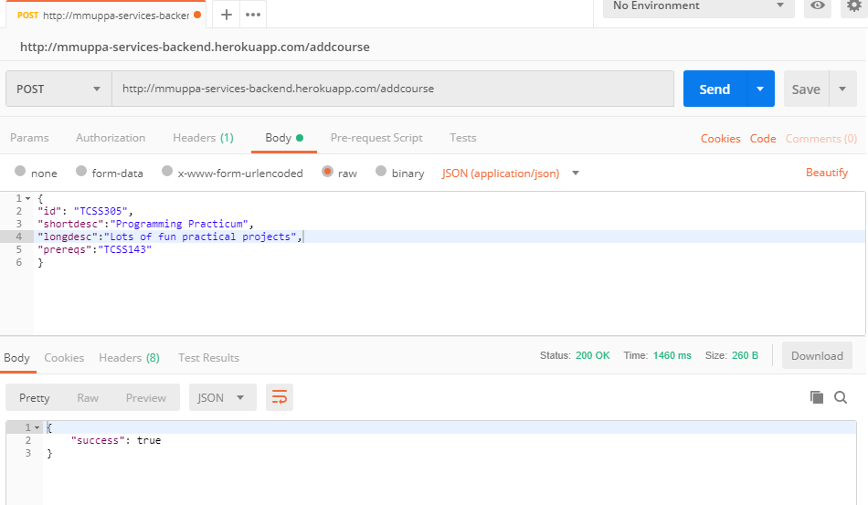
- Test that the web service is running for list of courses. In the URL field, enter the URL
https://uwnetid-services-backend.herokuapp.com/courses.
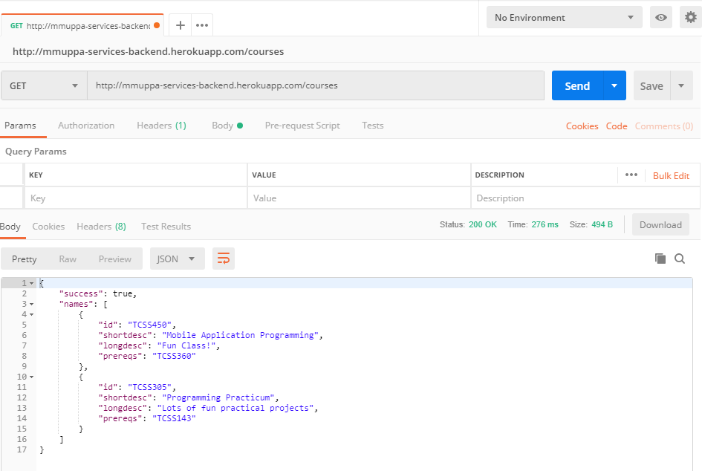
- You can see if the data was saved to the database by using the same URL but change the HTTP method to a get. Try it in Postman. Every time you send a message with POST, the text will be added to the courses table in the database. Add a couple more entries to the table. Remember that id must be unique since you can only enter one course with that name.
- Return to the terminal and log back into Heroku and the database. Refresher:
heroku login
heroku pg:psql
- To view all of the entries in the Demo table, type:
SELECT * FROM Courses;
- Did you see all your entries?

Run the web service locally
- It is convenient to run the webservice as a process on your local development environment. You may notice that git push heroku master can be time consuming and that time adds up when testing incremental changes. Luckily it is easy to run the service locally once a little setup is complete.
- For security purposes, it is advised to store your API keys, passwords, your database connection URL, etc. as an environmental/config variables. The process for this is easy using Heroku. You will have to do a couple of extra steps to set the variable when running your service locally.
- In a web browser, open your Heroku Dashboard. Navigate to your web service project for the labs. Click on the “Settings” tab then click on the “Reveal Config Vars” button.
- Notice that your database URL is already stored here with the name DATABASE_URL. In a later step, we will add other configuration variables.
- To see the “Config Vars” locally, open a terminal and navigate to your project. Log into Heroku CLI. Then type:
heroku config
NOTE: Keep the terminal open, you will use it in the following steps.
- You may now access these variables in your Node.js code but only when the project is run remotely on Heroku. The next steps will set up your local environment.
- You will need to add a file called .env to your project. In the terminal type:
heroku config:get DATABASE_URL -s >> .env
- This step creates a new .env file with your DATABASE_URL variable already included.
- You can repeat this step anytime you need to get an environmental variable from the Heroku app.
- Again, for security, you do not want to commit the .env file to version control. Add it to the .gitignore. Type:
echo .env >> .gitignore
NOTE: process.env is all you need to access the config vars.
- Test this change in your web service both locally and remotely. The demosql endpoint is appropriate for testing. To run the service locally and include the config vars, type:
heroku local
NOTE:
Use localhost:5000 instead of https://uwnetid-services-backend.herokuapp.com when testing in a browser or Postman.

NOTE:
End the process that is running your web service. In the Terminal, type:
<ctrl> c

Decompose index.js

Hello End Point
- The file index.js is starting to get busy. Let’s decompose it so that it is easier to manage. In node.js, any external file (and the functions in that file) are consider an external module. You have already used several external modules including express, form-data, and body-parser. In node.js, you may also create your own modules.
- In the directory, uwnetid-services-backend, create a new directory called routes. In this new directory, create a new javascript file called hello.js.
- Add the following to hello.js:
- //express is the framework we're going to use to handle requests
const express = require('express');
//retrieve the router project from express
var router = express.Router();
//add a get route to the router.
router.get("/", (req, res) => {
res.send({
message: "Hello, you sent a GET request"
});
});
//add a post route to the router.
router.post("/", (req, res) => {
res.send({
message: "Hello, you sent a POST request"
});
});
// "return" the router
module.exports = router;
- Notice the differences between these two functions and the functions for the hello endpoint in index.js. Remove the code that does these from index.js.
- Add the following line to index.js:
app.use('/hello', require('./routes/hello.js'));
- Remove the two functions for the /hello endpoints from index.js.
- SAVE both index.js and hello.js.
- Test the additions from your local machine. In the Terminal, type:
heroku local
- In a web browser, enter the URL localhost:5000/hello
- End the process that is running your web service. In the Terminal, type:
<ctrl> c

Params End Point
- In the directory, uwnetid-services-backend/routes create a new javascript file called params.js.
- Add the following to params.js:
//express is the framework we're going to use to handle requests
const express = require('express');
//Create a new instance of express router
var router = express.Router();
const bodyParser = require("body-parser");
//This allows parsing of the body of POST requests, that are encoded in JSON
router.use(bodyParser.json());
router.get("/", (req, res) => {
res.send({
//req.query is a reference to arguments in the url
message: "Hello, " + req.query['name'] + "!"
});
});
router.post("/", (req, res) => {
res.send({
//req.query is a reference to arguments in the POST body
message: "Hello, " + req.body['name'] + "! You sent a POST Request"
});
});
module.exports = router;
- Notice the differences between these two functions and the functions for the params endpoint in index.js. Also, notice that params.js needed another require/use function calls to handle parsing the arguments sent.
- Add the following just after the /hello endpoint add to index.js:
app.use('/params', require('./routes/params.js'));
- Remove the two functions for the /params endpoints from index.js.
- SAVE both index.js and params.js.
- Test the additions from your local machine. In the Terminal, type:
heroku local
- In a web browser, enter the URL localhost:5000/params?name=testing123
- End the process that is running your web service. In the Terminal, type:
<ctrl> c
- Check Point: Modularize the wait end point. Make sure this end point has both GET and POST functions.

Courses sql end point
- In the directory, uwnetid-services-backend/routes create a new javascript file called coursessql.js.
- Add the following to coursessql.js:
- const express = require('express');
//pg-promise is a postgres library that uses javascript promises
const pgp = require('pg-promise')();
//We have to set ssl usage to true for Heroku to accept our connection
pgp.pg.defaults.ssl = true;
//Create connection to Heroku Database
let db = pgp(process.env.DATABASE_URL);
if(!db) {
console.log("Please make sure that postgres is an addon!");
process.exit(1);
}
var router = express.Router();
const bodyParser = require("body-parser");
//This allows parsing of the body of POST requests, that are encoded in JSON
router.use(bodyParser.json());
router.post("/addcourse", (req, res) => {
// Parameters for the courses
let id = req.body['id'];
let shortdesc = req.body['shortdesc'];
let longdesc = req.body['longdesc'];
let prereqs = req.body['prereqs'];
if (id && shortdesc && longdesc && prereqs) {
db.none("INSERT INTO courses VALUES ($1, $2, $3, $4)", [id, shortdesc, longdesc, prereqs])
.then(() => {
//We successfully added the course, let the user know
res.send({
success: true
});
}).catch((err) => {
//log the error
console.log(err);
res.send({
success: false,
error: err
});
});
} else {
res.send({
success: false,
input: req.body,
error: "Missing required information"
});
}
});
router.get("/courses", (req, res) => {
db.manyOrNone('SELECT * FROM courses')
//If successful, run function passed into .then()
.then((data) => {
res.send({
success: true,
names: data
});
}).catch((error) => {
console.log(error);
res.send({
success: false,
error: error
})
});
});
module.exports = router;
- Notice the differences between these two functions and the functions for the coursessql endpoint in index.js. Also, notice that coursessql.js needed another require/use function calls to handle parsing the arguments sent. It also needs a DB object.
- Add the following just after the /params endpoint add to index.js:
app.use('/’, require('./routes/coursessql.js'));
- Remove the two functions for the sql endpoints from index.js.
- SAVE both index.js and coursessql.js.
- Test the additions from your local machine. In the Terminal, type:
heroku local
- In Postman, send a POST call to this end point and add an item to the DB.
- In a web browser, enter the URL localhost:5000/sql/courses

Modularize the DB connection
- In the directory, uwnetid-services-backend, create a new directory called utilities. In this directory, create a new javascript file called sqlconn.js.
- Move the following code from to sql_conn.js:
//pg-promise is a postgres library that uses javascript promises
const pgp = require('pg-promise')();
//We have to set ssl usage to true for Heroku to accept our connection
pgp.pg.defaults.ssl = true;
//Create connection to Heroku Database
let db = pgp(process.env.DATABASE_URL);
if(!db) {
console.log("Please make sure that postgres is an addon!");
process.exit(1);
}
module.exports = db;
- Delete the db code from coursesql.js and add the following line.

const db = require('../utilities/sqlconn.js');
- SAVE all files.
- Test the changes from your local machine. In the Terminal, type:
heroku local
- In a web browser, enter the URL localhost:5000/demosql
- In Postman, send a POST call to this end point and add an item to the DB.

Register Service
- In the directory, uwnetid-services-backend/routes create a new javascript file called register.js.
- Before we add code to register.js, the register function requires the Salt/Hashing and sendEmail functions. Luckily, we already have a place for utility functions.
- Create utils.js to add the following:
//Get the connection to Heroku Database
let db = require('./sqlconn.js');
//We use this create the SHA256 hash
const crypto = require("crypto");
function sendEmail(from, receiver, subj, message) {
//research nodemailer for sending email from node.
// https://nodemailer.com/about/
// https://www.w3schools.com/nodejs/nodejs_email.asp
//create a burner gmail account
//make sure you add the password to the environmental variables
//similar to the DATABASE_URL and PHISH_DOT_NET_KEY (later section of the lab)
//fake sending an email for now. Post a message to logs.
console.log('Email sent: ' + message);
}
/**
* Method to get a salted hash.
* We put this in its own method to keep consistency
* @param {string} pw the password to hash
* @param {string} salt the salt to use when hashing
*/
function getHash(pw, salt) {
return crypto.createHash("sha256").update(pw + salt).digest("hex");
}
module.exports = {
db, getHash, sendEmail
};
- Notice that module.exports now exports three elements, one is an Object the other two are functions.
- Run the script for members.sql to create the Members table.
- Add the following to register.js:
- //express is the framework we're going to use to handle requests
const express = require('express');
//We use this create the SHA256 hash
const crypto = require("crypto");
//Create connection to Heroku Database
let db = require('../utilities/utils').db;
let getHash = require('../utilities/utils').getHash;
let sendEmail = require('../utilities/utils').sendEmail;
var router = express.Router();
const bodyParser = require("body-parser");
//This allows parsing of the body of POST requests, that are encoded in JSON
router.use(bodyParser.json());
router.post('/', (req, res) => {
res.type("application/json");
//Retrieve data from query params
var first = req.body['first'];
var last = req.body['last'];
var username = req.body['username'];
var email = req.body['email'];
var password = req.body['password'];
//Verify that the caller supplied all the parameters
//In js, empty strings or null values evaluate to false
if(first && last && username && email && password) {
//We're storing salted hashes to make our application more secure
//If you're interested as to what that is, and why we should use it
//watch this youtube video: https://www.youtube.com/watch?v=8ZtInClXe1Q
let salt = crypto.randomBytes(32).toString("hex");
let salted_hash = getHash(password, salt);
//Use .none() since no result gets returned from an INSERT in SQL
//We're using placeholders ($1, $2, $3) in the SQL query string to avoid SQL Injection
//If you want to read more: https://stackoverflow.com/a/8265319
let params = [first, last, username, email, salted_hash, salt];
db.none("INSERT INTO MEMBERS(FirstName, LastName, Username, Email, Password, Salt) VALUES ($1, $2, $3, $4, $5, $6)", params)
.then(() => {
//We successfully added the user, let the user know
res.send({
success: true
});
sendEmail("uwnetid@uw.edu", email, "Welcome!", "<strong>Welcome to our app!</strong>");
}).catch((err) => {
//log the error
console.log(err);
//If we get an error, it most likely means the account already exists
//Therefore, let the requester know they tried to create an account that already exists
res.send({
success: false,
error: err
});
});
} else {
res.send({
success: false,
input: req.body,
error: "Missing required user information"
});
}
});
module.exports = router;
- Add the following just before the /hello endpoint add to index.js:
app.use('/register', require('./routes/register.js'));
- SAVE all files.
- Test the additions from your local machine. In the Terminal, type:
heroku local
- In Postman, send a POST call to the register end point. Use the following JSON in the body of the POST:
{
"first":"test",
"last":"test1",
"email":"uwnetid@fake.email.com",
"username":"test",
"password":"test"
}
- Make the call twice. Notice the different results? Also notice the console output.
- Register yourself as a user. Make sure you use a valid email address.
- Push the changes to Heroku and test on the server.

Setup Webservice to use JSON Web Tokens (JWT)

Setup the module and security key
- Open and edit index.js. Add the following line.
let middleware = require('./utilities/middleware');
- In a web browser, open your Heroku Dashboard. Navigate to uwnetid-services-backend web service project. Click on the “Settings” tab then click on the “Reveal Config Vars” button.
- In the empty fields below DATABASE_URL, add:
JSON_WEB_TOKEN in the “Key” field and type a secret value for the Value. The actual text that you put here does not matter. This is the secret key that is used when generating and validating the JSON Web Tokens.
- Click the Add button next to the fields. It will take about a minute to load the variable.
- To test that the new variable is applied, open a terminal and navigate to your project. Log into Heroku CLI. Then type:
heroku config
- NOTE: Keep the terminal open, you will use it in the following steps.
- You are may now access these variables in your Node.js code but only when the project is run remotely on Heroku. The next steps will set up your local environment.
- To add the secret value to your .env file, type:
heroku config:get JSON_WEB_TOKEN -s >> .env

Login Service
- In the directory, uwnetid-services-backend/routes create a new javascript file called login.js.
- Add the following to login.js:
- //express is the framework we're going to use to handle requests
const express = require('express');
//Create connection to Heroku Database
let db = require('../utilities/utils').db;
let getHash = require('../utilities/utils').getHash;
var router = express.Router();
const bodyParser = require("body-parser");
//This allows parsing of the body of POST requests, that are encoded in JSON
router.use(bodyParser.json());
//Pull in the JWT module along without a secret key
let jwt = require('jsonwebtoken');
let config = {
secret: process.env.JSON_WEB_TOKEN
};
router.post('/', (req, res) => {
let email = req.body['email'];
let theirPw = req.body['password'];
let wasSuccessful = false;
if(email && theirPw) {
//Using the 'one' method means that only one row should be returned
db.one('SELECT Password, Salt FROM Members WHERE Email=$1', [email])
.then(row => { //If successful, run function passed into .then()
let salt = row['salt'];
//Retrieve our copy of the password
let ourSaltedHash = row['password'];
//Combined their password with our salt, then hash
let theirSaltedHash = getHash(theirPw, salt);
//Did our salted hash match their salted hash?
let wasCorrectPw = ourSaltedHash === theirSaltedHash;
if (wasCorrectPw) {
//credentials match. get a new JWT
let token = jwt.sign({username: email},
config.secret,
{
expiresIn: '24h' // expires in 24 hours
}
);
//package and send the results
res.json({
success: true,
message: 'Authentication successful!',
token: token
});
} else {
//credentials did not match
res.send({
success: false
});
}
})
//More than one row shouldn't be found, since table has constraint on it
.catch((err) => {
//If anything happened, it wasn't successful
res.send({
success: false,
message: err
});
});
} else {
res.send({
success: false,
message: 'missing credentials'
});
}
});
module.exports = router;
- Add the following just before the /register endpoint add to index.js:
app.use('/login', require('./routes/login.js'));
- SAVE all files.
- Test the additions from your local machine. In the Terminal, type:
heroku local
- In Postman, send a POST call to the login end point. Use the following JSON in the body of the POST:
{
"email":"uwnetid@fake.email.com",
"password":"test"
}
- Make the call with incorrect credentials.
- Push the changes to Heroku, test Login.

